Bug Report - 01:

Cash Deposit accepts excessively large or small numbers
Environment: Windows 11, Opera GX
Test Object: Cash Deposit

Preconditions:
- The website is open
- The user is logged into an active demo account (e.g., 12345678)

Steps:
- Enter account number 12345678 and submit
- Enter PIN 1234 and submit
- Click on 'Cash Deposit'
- Enter an excessively large number (e.g., 50 digits long)
- Submit the deposit

Expected Result:
- The system should enforce realistic boundaries for deposit amounts and reject overly huge numbers

Actual Result:
- The system accepts the input and displays the extremely large number formatted in scientific notation (e.g., 1e+54)
Attachment:
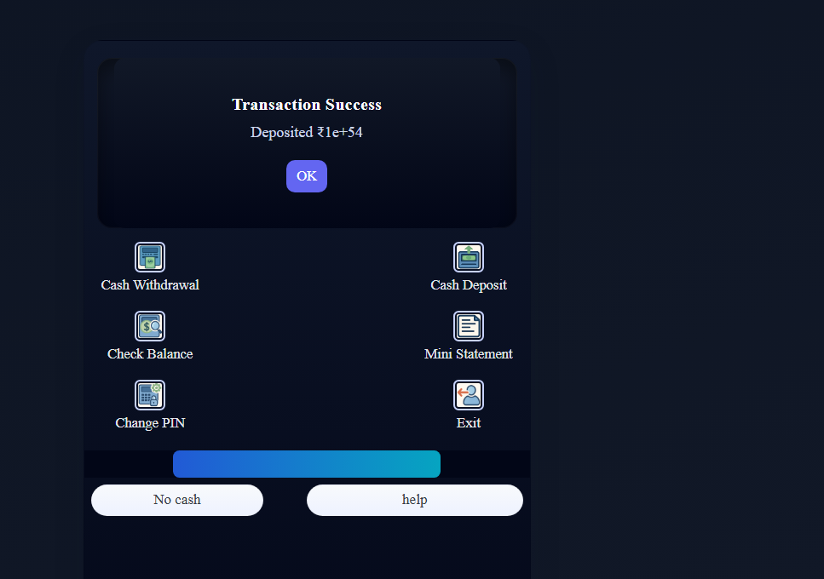
Severity: High
Priority: High

